**D2: discuss the techniques that can be used on web pages to aid user access to information**

**Introduction**

In this report, I will discuss the techniques that is used to help user access information for e-commerce websites. In addition, screenshots will be included.

**Google**

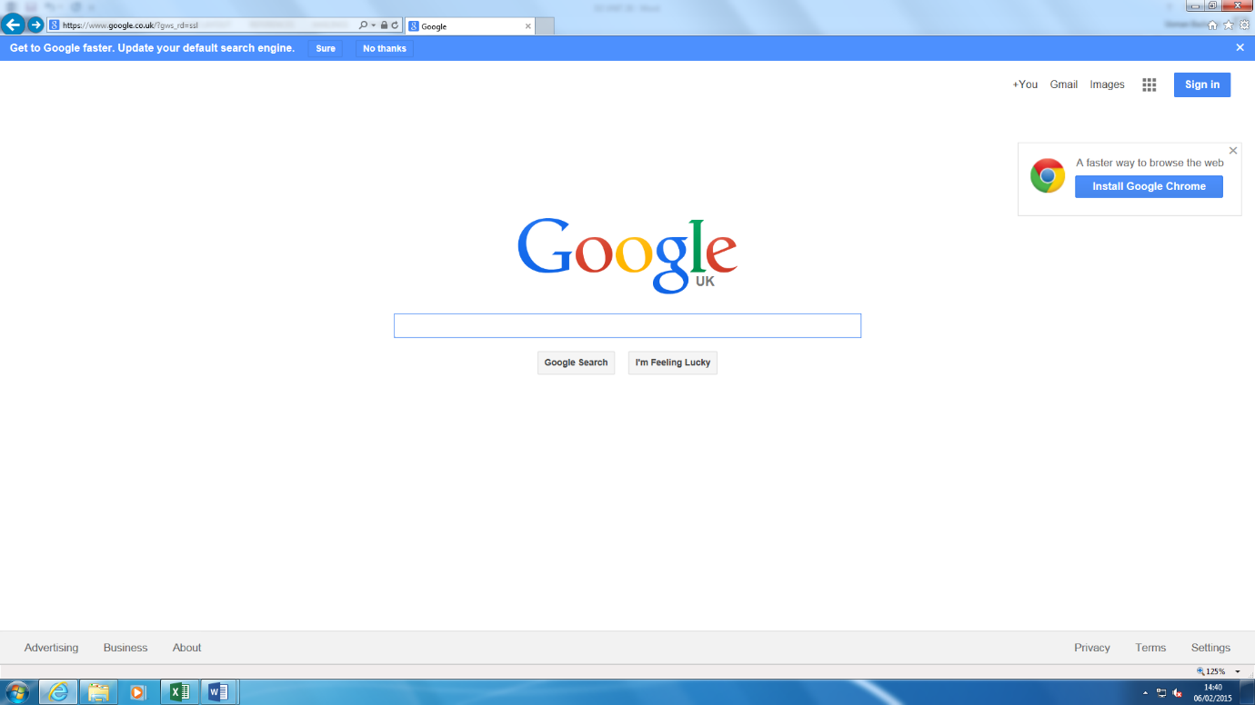Google is a clear example of why it helps users’ access information. A clear picture below shows the user how to find information.

The user types in this search box what they want to find.

This is where the user wants to access more information. For example, Maps, Images, Gmail, and many more.

This shows the user what Google is about.

This is the UK version of Google. If you type in [www.google.ac](http://www.google.ac), it would enable the information that is available in the country. [www.google.co.uk](http://www.google.co.uk) shows that the information available is within the UK. And, this is the Google logo.

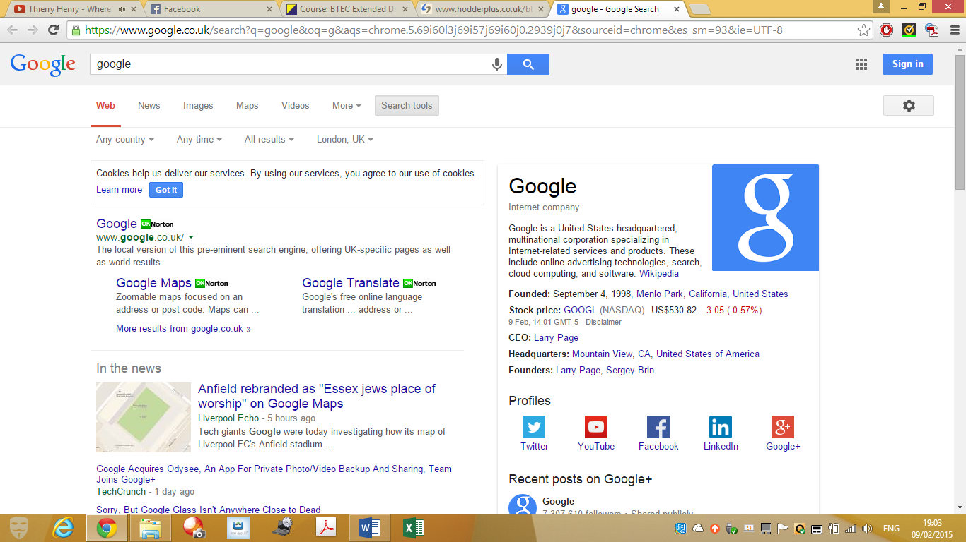

This helps the user by finding something they cannot find.

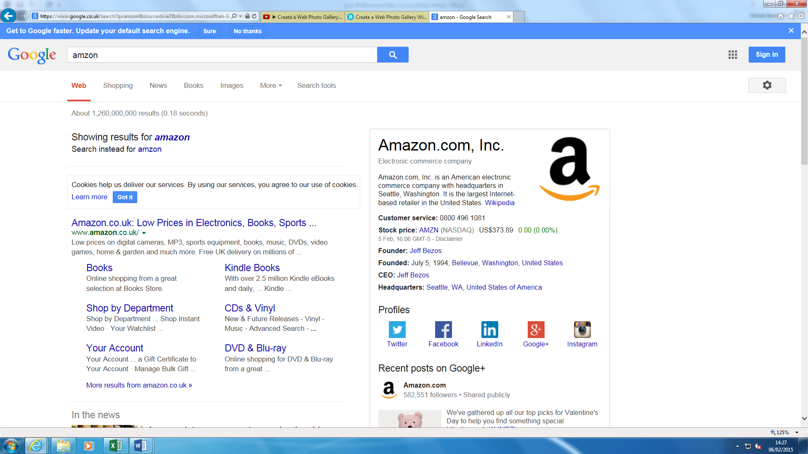When a user is trying to access information, he needs to consider how he is going to find it. Every website has different ways of portraying and showing information. One of the techniques that helps users get access to information is correct spelling. This is very important for any website. If the user does not know how to spell e.g. Amazon, he would be stuck trying to find the website. However, search engines aid users to get to the website they want. This picture is a clear example of how information is found. I typed in purposely ‘Amzon’ to find the Amazon website. This search engine showed what I meant. Even if I have typed it wrong, the website that I was trying to find has come up anyway. Google is a helps the user find information in a clever way.

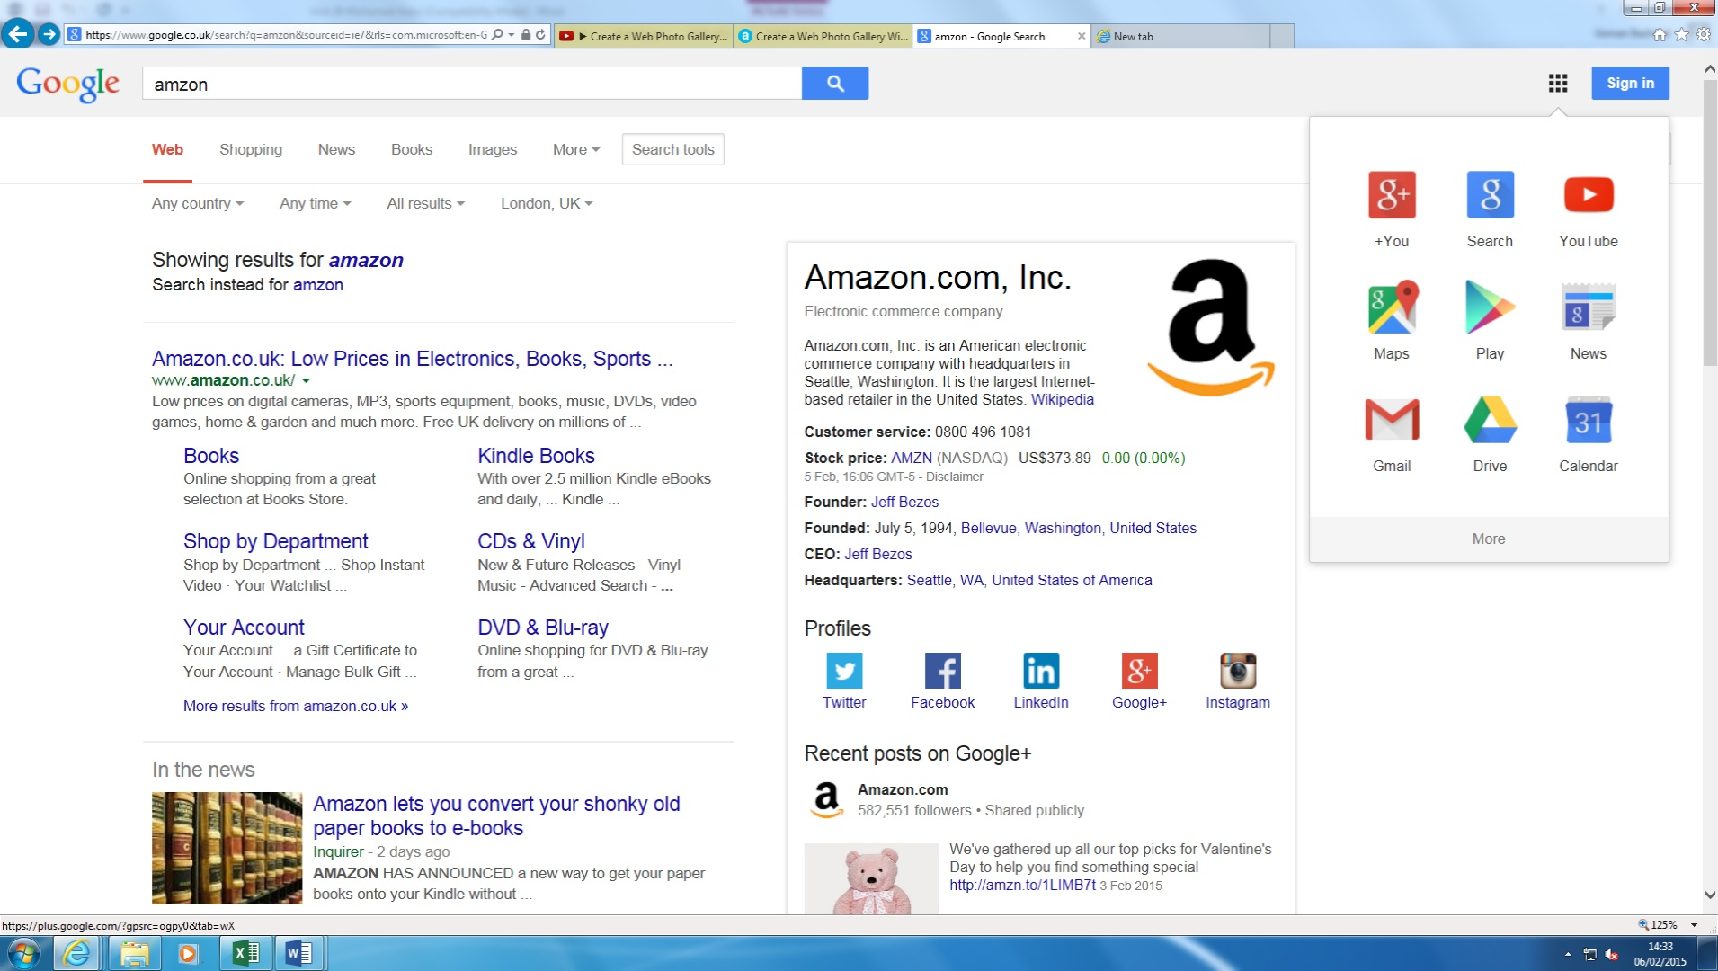Another technique that helps the user find information on Google is that options are varied in to what the user is trying to find. If you are not sure where to go, you can click on Maps and find your way. They are more options to find. This is very helpful for any user.



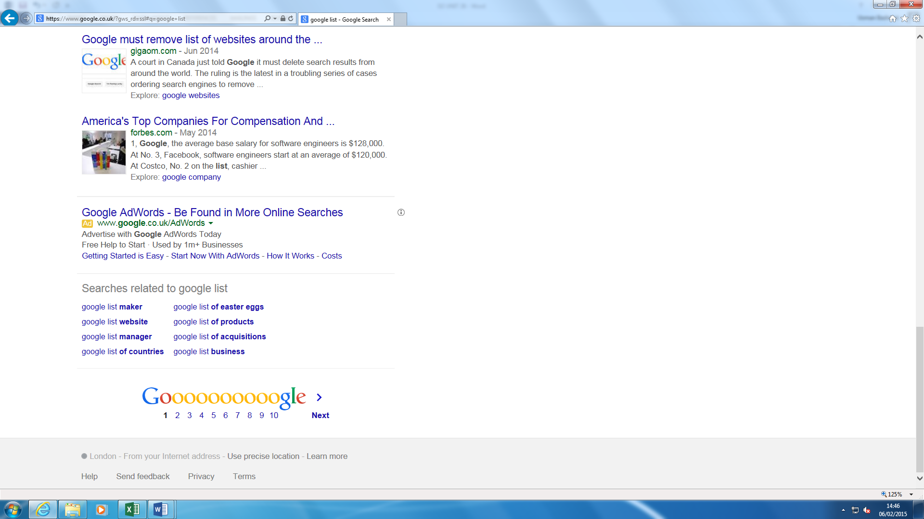Another technique that is used to aid user information is that the order it is laid out. Websites pay search engines to put them above the list on Google. For example, the website I have made, if I pay Google to put me in at the top of the list. When the user searches Soccer Manager News, the website would come up straight away. This helps access user information by not making it hard for the user to find the information they are trying to find.